¿According to polls, which of the following traits would be the biggest liability for a US presidential candidate: past marijuana use, gay or lesbian, Mormon, Muslim, atheist?

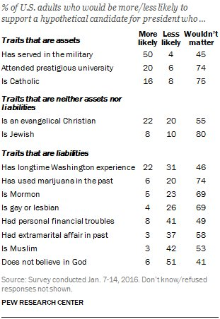

How accurate was your prediction?

How surprising was the information in the chart?

How do you think this chart will be different for the 2048 election?

Is this information good news?

Consider all the traits in the chart and evaluate whether each trait would make your vote for a candidate more likely, less likely, or wouldn't matter:

How different was your evaluation of presidential traits from that of the average American's?

What questions do you have about the chart?

Explain how the information from the chart impacts any of the current presidential candidates:

List two generalizations you can make about American presidential trait preferences from the information in the chart:

In the comments section, using the information from the chart, create an extremely unelectable presidential candidate:

Action Extension

Do one of the following:

Contact the Democratic National Party or the Republican National Party and give them five pieces of advice on nominating a presidential candidate based on the information in the chart:

Write a letter to the American people telling them what they are wrong about regarding their desired traits for presidential candidates. Post it on social media or send it to your local newspaper (if you still have one).

Make a poster or flyer or video advertisement for the unelectable presidential candidate you created in question 9 above.

Learning Extension

Read the entire Pew report on presidential candidate traits.

