Global Languages

¿What is the most spoken language in the world?
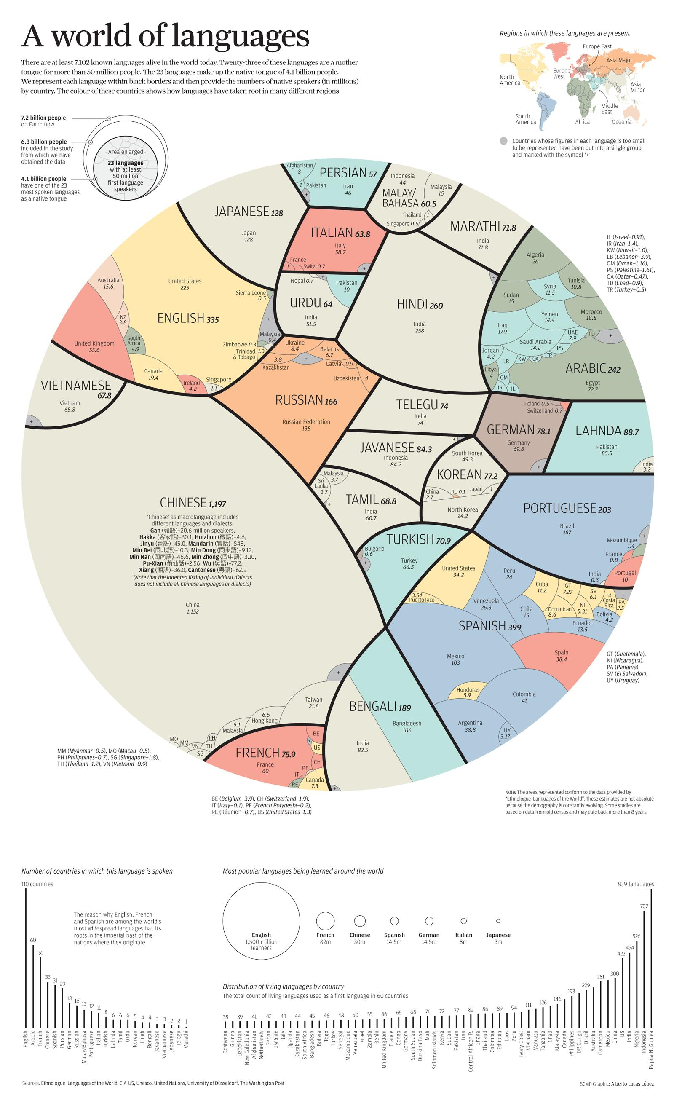
- How accurate was your prediction?
- What was most surprising about this information?
- Would you say there is such thing as a global language?
- Is this infographic good news or bad news?
- What does globalization have to do with this infographic?
- How many languages do you speak?
- Just 500 years ago, less than 5 million people spoke English. Why has that number grown so much?
- How do you think the globalization of language and spread of English has affected your life?
- One entire language is lost every 14 days. What do you think globalization has to do with this?

