What U.S. Federal agency is the most popular?
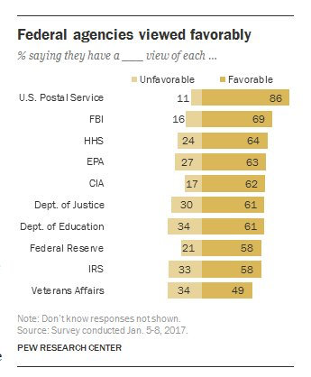

How accurate was your prediction?

What most surprised you about this information?

Why do you think so many people have a positive opinion of the US Postal Service?

What was the least popular federal agency in this list?

Why do you think that is?

Overall, would you say that Americans have a favorable view of federal agencies?

What is a consequence of this data?

Is this good news? Do you even know what each of these agencies does? If not, educate yourself.

What is your absolute favorite federal agency?

Write a rap about it and submit it to your teacher!

According to this data, Americans seem to like most federal agencies. At the same time, most people hold negative opinions about the president, the congress, and the US government in general. Explain those seemingly contradictory positions.

Why isn't NASA at the top of the list?

Donald Trump has already announced a hiring freeze on almost all federal agencies. How do you think that will effect their ability to operate?

No one enjoys paying taxes, yet 58% of Americans approve of the IRS. Explain this apparent contradiction. Over the past 8 years of the Obama administration, the public's favorable opinion of these agencies generally increased. What effect do you imagine the Trump administration will have on the public's opinion of federal agencies?

How do you think partisanship affects opinions of the federal agencies?

How different do you imagine these numbers would be in a one-party country like Cuba, China or Russia?

Learning Extension

Read the Pew report on Americans' opinions of federal agencies

Action Extension

Show 10 people a list of these ten agencies. How many of them can even tell you what each agency does? Ask them to evaluate each agency as favorable or unfavorable. Compile your data to show the aggregate opiniion of each agency and compare your score to the American public's. Share your results online or in class.

Bonus Chart
