In your state, what is the most commonly held job by immigrants?

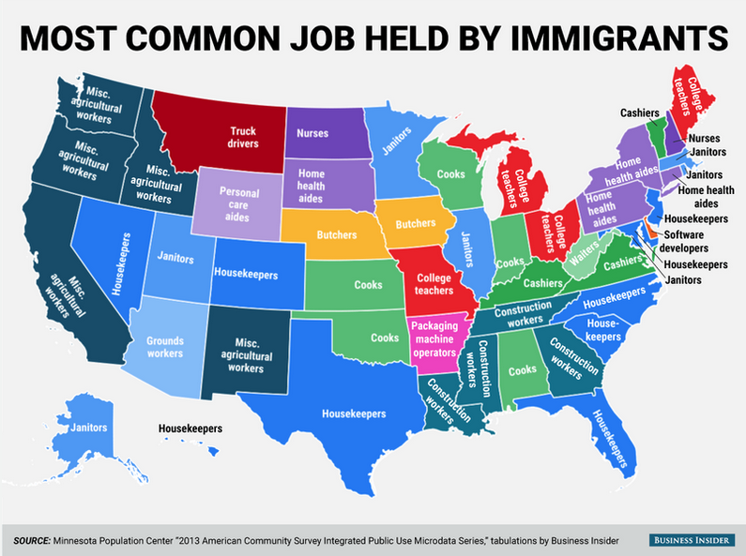

How accurate was your prediction?

What story does this map tell?

What most surprised you about this information?

How many first generation immigrants do you know?

Is the information in this map good news or bad news?

How different do you think this map would have been a century ago?

Which state's data is the most similar to what you expected?

Which state's data is the least similar to what you expected?

Based on this map, what generalizations can you make about immigrant jobs in America.

Why do immigrants come all the way to our county for these jobs which are generally low-pay and low-prestige?

Explain how the sorts of jobs depicted in the map being held by immigrants impacts American workers.

Explain how the data from this map impacted the 2016 presidential election.

Describe the story of your family's immigration to the US?

If Donald Trump had his way & the US erected an impassable border fence & then evicted all the undocumented aliens, how would our country be different?

In the comments section below, advise an immigrant about whether they should move to the US or not:

Learning Extension

Read the NY Times story, Losing hope in the U.S., Migrants Making Icy Crossing to Canada.

Action Extension

Everyone has a different story, but whether it was crossing the Bering Strait on foot, surviving the Middle Passage in the belly of a slave ship, slipping across the Sonoran Desert at night, or steaming the Atlantic from Liverpool, at some point, everyone's family immigrated to the US. Talk to your parents and relatives to find out more about your family's immigration story. Share the details of your immigration story online or in class.

