Global Technology
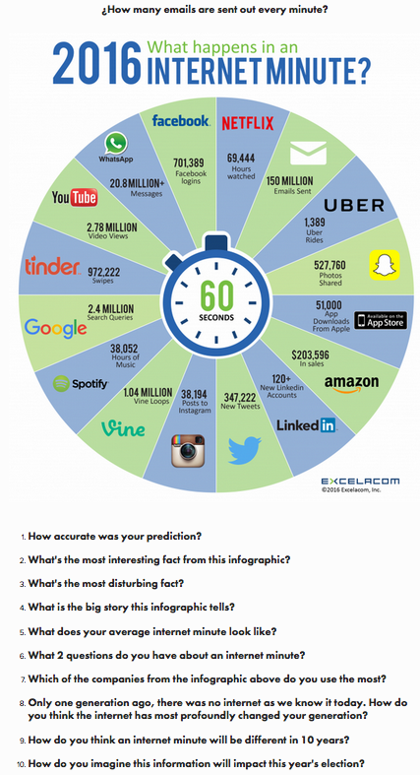

- How accurate was your prediction?
- What’s the most interesting fact from this infographic?
- What’s the most disturbing fact?
- What’s the most surprising fact?
- What is the big story this infographic tells?
- Is this good news?
- What does this infographic tell you about globalization?
- What question do you have about this infographic?
- Which of the companies in the infographic do you use the most?
- Only one generation ago, there was no internet as we know it today. How do you thin the internet has most profoundly changed your generation?
- How do you think an internet minute will be different in 10 years?
- Do you control the internet more than it controls you?

