What has happened to the number of sentenced inmates in federal custody (federal prisoners) over the past 30 years?

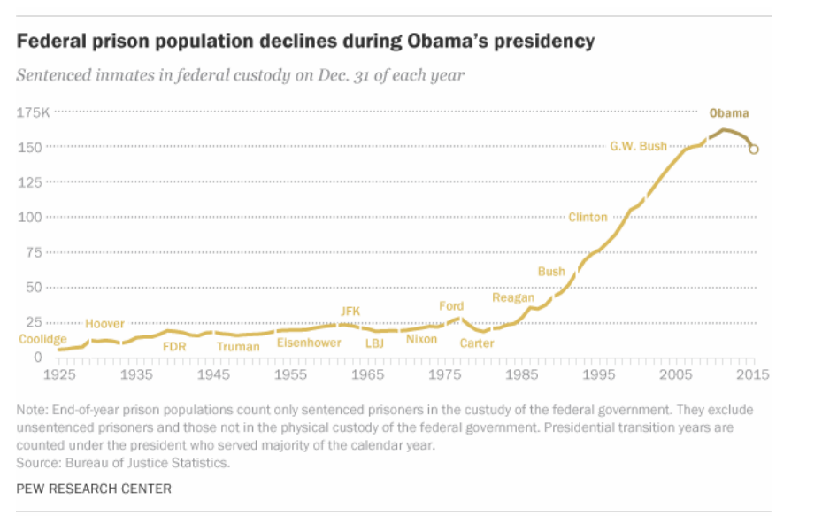
- How accurate was your prediction?
- What is the big trend over the past 30 years?
- Why do you think that is?
- What is one consequence of this trend?
- Who pays for this all?
- Is this good news?
- What is one thing a president could do about this?
- What is one thing a citizen could do about this?
- Based on the data from the chart, which president would you hold most responsible for increasing the number of federal prisoners?
- Describe the trend in the number of federal inmates during President Obama's time in office?
- Why do you think that is?
- What do you imagine the trend will be like under Donald Trump?
- If you were president explain whether you would try to increase or decrease the federal prison population.

Learning Extension

Read the Pew Research Center's report on incarceration.

Action Extension

Contact Donald Trump and express your opinion about whether or not he should follow President Obama's direction of reducing the federal prison population.

Visual Extension
