In 2016, what was the chance that a self-funded candidate in a federal race (candidates who put at least $500,000 into their runs) won their campaign?*

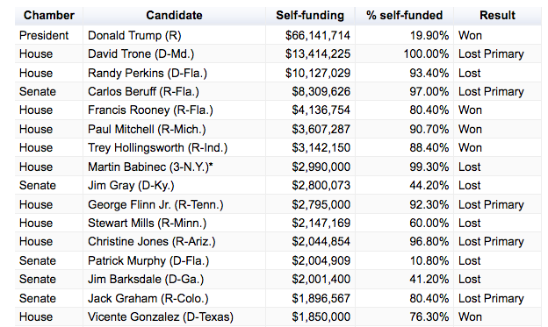

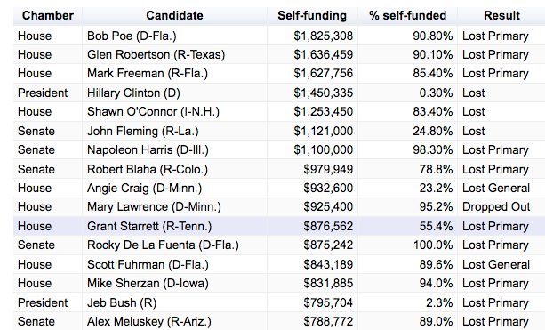

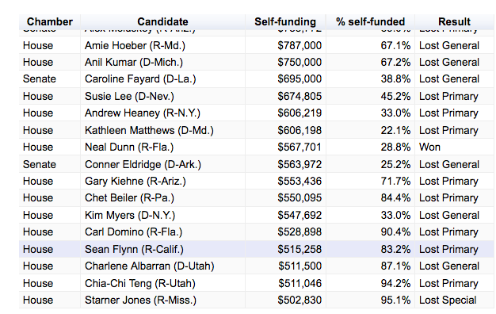

*12.5% overall
- How accurate was your prediction?
- How surprised are you by this information?
- Is this good news?
- What is the big story this data tells?
- Why do you think that is?
- What is one consequence of politicians self-funding their own campaigns?
- Do you think that self-funding is good for democracy?
- What would Thomas Jefferson (Anti-federalist) and Alexander Hamilton (Federalist) say about self-funded campaigns?
- Are you surprised that Trump self-funded about 20% of his campaign?
- Are you surprised that Hillary Clinton funded over $1.5 million of her campaign?
- Had Trump not self funded over $60 million of his run do you think he would have won?
- Why do you think that almost 88% of self-funders lost election, but Donald Trump won his?
- In the future do you think there will be more self-funded elections?
- What do you think is one reason that so many self-funders lose election?
- I taught a student in 2004 whose father spent $2 million of his own dollars to run for the US House of Representatives. He didn't even win the primary. What advice would you give him?
- All the 6 self-funded campaigns that won in 2016 were first-time campaigners. Why do you think that is?
- Let's imagine that you had tons of money: specifically, $58 million dollars in the bank. Would you spend $1 million to buy, I mean run for a US House seat?

Learning Extension

Read the Open Secrets report on 2016 self-funded campaigns, while supplies last.

Action Extension

Borrow $66 million from Donald Trump to run for president. If that doesn't work, ask 10 people to estimate how much of their own money Clinton and Trump spent on their campaigns and compare the results to reality. Post your findings online or share them in class.

