What portion of Americans answered the following question about the American Dream, yes? "Do you think it is possible to start our poor in this country, work hard and become rich?"
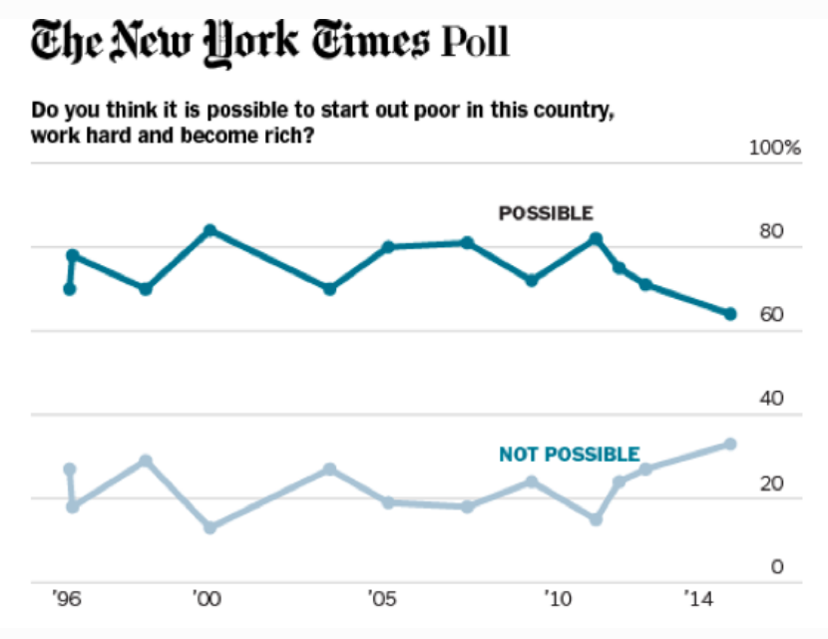
- How accurate was your prediction?
- Do you think it is possible to start out poor in this country, work hard and become rich?
- In what way is the information from this poll surprising?
- What has happened to the American public's faith in the American Dream?
- Why do you think Americans have less faith in the American Dream than they once did?
- What is one consequence of this change?
- What questions do you have about this chart?
- Is this good news or bad news?
- Explain what you think this chart will look in 30 years:
- Explain any connection between our most recent election and the American Dream.
- In what way do you think a Clinton and Trump supporter would disagree about the American Dream?
- In what way would they agree?
- Do you think there's anything the US government can do to make people believe in the American Dream again?
- In the comments section, tell us what you would say to an immigrant thinking about moving to America to pursue the American Dream?

Action Extension

Survey ten people, in person or on the internet, and ask the same question about the American Dream, as asked in the NYTimes Poll above. Tally your scores, along with an explanation for any differences between your survey and the NYTimes Survey, and share your answers with class or online.

Learning Extension

Check out the bonus chart below:

