How much has interpersonal trust declined since 1972 in the U.S.?
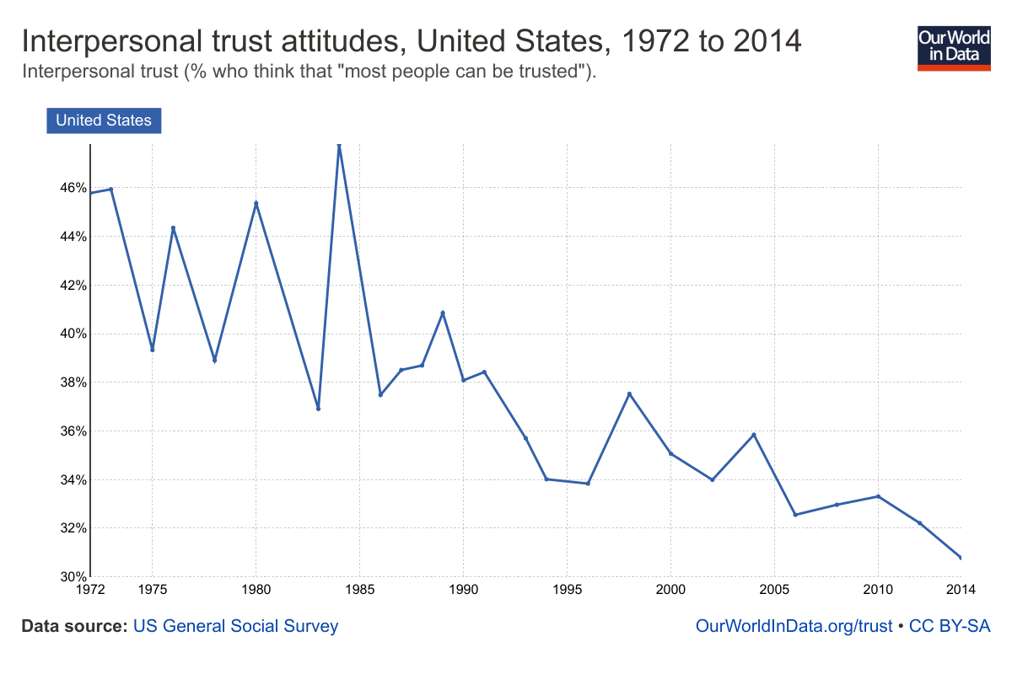

- How accurate was your prediction?
- What most surprised you about this data?
- What is one trend you see in the chart?
- What are two factors that explain that trend?
- What are two consequences of this trend?
- Based on the trends in this chart and in the recent presidential election, what do you imagine the level of interpersonal trust in the US will be over the next eight years?
- What effect do you imagine this lack of trust had on the most recent presidential election?
- What effect does this lack of trust have on American politics?
- Do you trust most people?
- Explain your answer.
- What questions do you have about this?
- How different do you think this data would be in other countries?

Bonus Maps
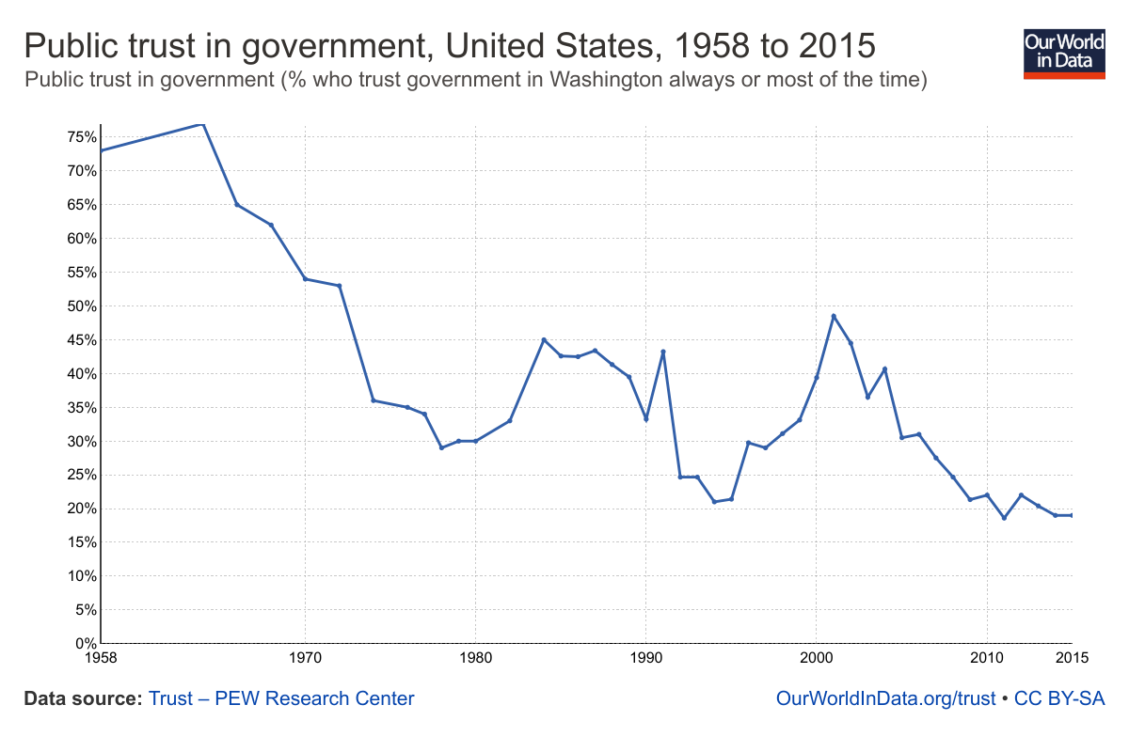
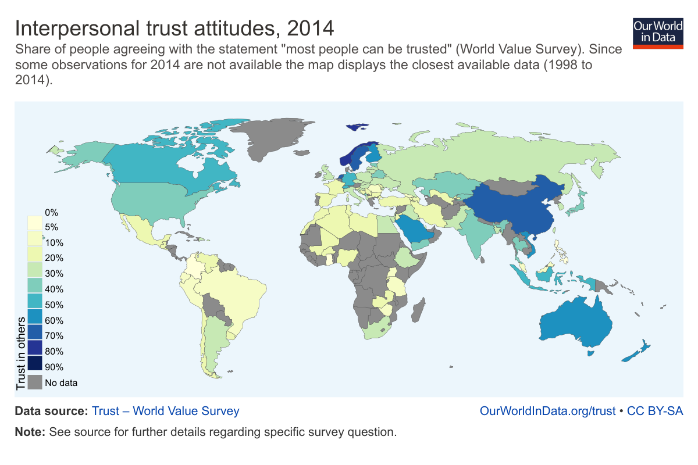

Learning Extension

Check out all these amazing charts about trust from the inimitable Max Roser.

Action Extension

Complete our Trust Lab on our Commonweal Site then share your response on social media and in class.

