Which of the following variables has the most significant impact on voting rates: Age, Income, or Education?
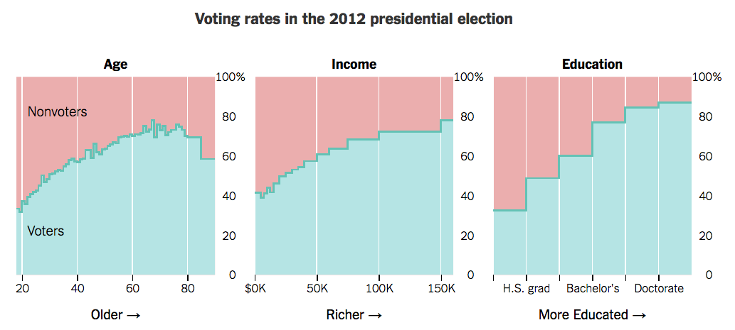

How accurate was your prediction?

What about this information was the most surprising?

Write a headline to summarize the findings of the three charts:

What is one trend you see in the charts?

Why do you think that is?

What is one consequence of this trend?

Can you draw one conclusion about the 2016 election based on the charts?

Is this information good news?

Will this information be more likely to result in a win for Donald Trump or Hillary Clinton?

Is the information presented in the chart mostly accurate for the people you personally know?

Learning Extension

Browse at all the amazing voting rate charts from The Upshot.

Action Extension

Design the profile of the person who would be the MOST likely American to vote in the next presidential election. Be creative and accurate. Tell us their name, age, and education level: And you can use the charts fromThe Upshot to add in even more details about them. Share this super-voter with class. Have a competition to see whose voter is the most likely to vote. BONUS: Design the profile of the person who would be the LEAST likely American to vote in the next presidential election:

