What portion of American adults think immigrants are making American society better in the long run?
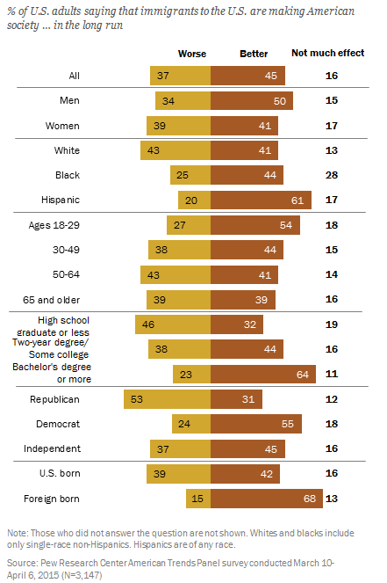
- How accurate was your prediction?
- What most surprised you about this information?
- What are two trends do you see in the chart?
- What is the big story the chart tells?
- Why do you think this is?
- What is the consequence of this?
- How will the information from this chart affect the 2016 election?
- Which of the demographic groups listed in the chart would be most likely to vote for Donald Trump who has vowed to deport 11 million undocumented immigrants?
- You are an immigrant. If we go far enough back, we all are (even Native Americans). When did your family immigrate to the US?
- Do you think immigrants are making American society better in the long run?

Learning Extension

Behold this very cool interactive chart on the % of Americans who are foreign born citizens from the Pew Research Center report on Immigration.

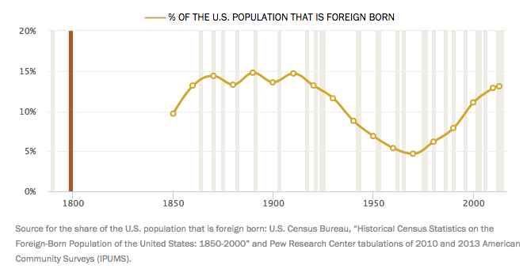

Action Extension

Browse the Clinton and Trump policy positions on immigration and support the candidate (vote, put up a sign, plaster a bumper sticker, campaign, get out the vote, donate) you'd prefer to become America's 45th president.

